12 January 2017

* * * FOR IMMEDIATE RELEASE * * *

Eleven Magazine Launched the First Edition of BIOMIMICRY: An architecture and design competition focused on nature-inspired innovation.

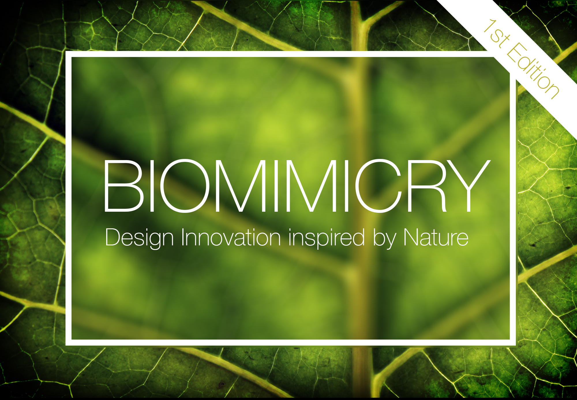

COMPETITION INFORMATION:

Nature is the ultimate designer.

Resourceful, ingenious, sustainable, beautiful; Nature is a true teacher in innovation.
Some of the brightest minds in history – from Leonardo da Vinci to Albert Einstein – have been inspired and guided by its systems and creations. Some of mankind’s biggest inventions have come from observing nature’s variety and insightful ways of working and solving problems.

Today, we face a world of challenges in our society. For designers, challenges become opportunities to innovate. But in an era of renewed urgency towards a more sustainable future, how can nature inspire the next generation of designers?
This is where Biomimicry in design really comes into its own.

Defined by the Biomimicry Institute as; “an approach to innovation that seeks sustainable solutions to human challenges by emulating nature’s time-tested patterns and strategies”, Biomimicry can be seen as one of the most fascinating and important methodology a designer can adopt today.

Nature is a balanced ecosystem. By studying its designs, one can extract clever ways of problem solving, which we – as humans – can then translate into our own contexts. Because this is a way of emulating natural processes, Biomimicry assures a more sustainable approach to man-made change; one that is much more in sync with the world we inhabit.

Flight, aerodynamics, green energy, fractal designs and advances in material technology are but a small fraction of things we have learnt from studying nature’s creations and the systems behind them.

Inspiration is everywhere in nature. Whether we can seek it in its beauty or find it in its functionality, Biomimicry in design always leads to fascinating outcomes!

Call for Entries:

Eleven Magazine seeks nature-inspired designs in the fields of Architecture, Design, Technology and Fashion that showcase innovation and biomimicry practices.

What this means is ultimately up to you.

Designs can be existing prototypes or new conceptual ideas. So, if you have a biomimicry idea, then we would love to see it!

Biomimicry (A Definition):

(noun)

The design and production of materials, structures, and/or systems that are modelled on and inspired by biological entities and processes.

Confirmed Jury (so far)

- Richard James MacCowan (Biomimicry Institute UK)
- Timothy McGee (LikoLab)
- Yaniv Peer (Exploration Architecture)
- Jan Utzon (Utzon Associate Architects)
- Alexander Walter (Editor, Archinect / Bustler)
- Marko Brejovic (Atelier Marko Brajovic)
- Andrea Verenini (Editor, Eleven Magazine)

Prizes + Awards:

Winner: £2000 GBP + induction into Eleven’s Hall of Fame + invited to join the jury for Eleven’s next competitions.

Runner Up: £400 GBP

Honourable Mentions (x6): no cash prize (boo!) but lots of glory nonetheless (yay!)

In addition to the jury determined prizes, the public will be able to vote for their favourite entry online, who will win the People’s Choice Award.

People’s Choice Award: £100 GPB + Induction into Eleven’s Hall of Fame
(this award is voted by the public online)

All our awarded teams will be published in Eleven Magazine and Eleven’s media partners, and will receive one free pass voucher to join future competitions by Eleven.

Competition Type:

- Open, single-stage international competition.
- Conceptual / Ideas / Prototypes
- Students
- Professional

Registration Fee:

Early Bird: £60 GBP

Standard: £80 GBP

Late Bloomer: £100 GBP

Competition Schedule:

11 November 2016: Registration opens. Early Bird fee applies.

1 December 2016: Standard Fee applies

1 March 2017: Late Bloomer fee applies

11 March 2017: Registration Closes. Projects submission deadline.

14 March 2017: Public online voting for People’s Choice Award opens.

9 May 2017: Public online voting for People’s Choice Award closes.

11 May 2017: Winners Announced and published!

Registration/Submission Deadline:

11th March 2017 at 11:00am (UK Time)

++ For more information, or to join the challenge, please visit
www.eleven-magazine.com/competitions ++

(end)

Notes to the Editor:

For any further information or if you have any questions, please email Miss Eloise Carr on eloise@eleven-magazine.com

We would really appreciate if you could let us know if you will support our competition and feature it on your site.

ABOUT ELEVEN:

Eleven is an online architecture platform interested in innovation through design. Part of what we do is organise and run international design-led competitions. We plan to run several design and architecture competitions a year. Past competitions designed and run by Eleven include the award-winning Cambodia 2015 (3rd place in Buster’s Competition of the Year Award 2015, exhibited in London’s Covent Garden and Boston’s BAC), San Francisco 2016, and award-winning Moontopia (7th place in Buster’s Top Ten Best Competitions of the Year Award 2016).

IMAGE CREDITS:

Please credit all images and photographs to ‘Eleven Magazine Ltd.’. Thank you.

If you require banners or different image ratios, please contact Miss Eloise Carr on eloise@eleven-magazine.com

Thank you.

